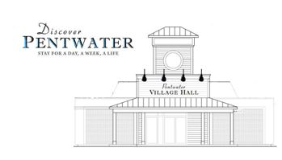
Short-Term Rental 2026
2026 RENEWAL Application
Village of Pentwater
65 S. Hancock St. - PO BOX 622
Pentwater, MI 49449-0622
231-869-8301

Pentwater Property Address: _____________________________ STR Max Occupants: _______
Parcel ID: 64 – 044- ____ ____ ____ - ____ ____ ____ - ____ ____

Property Owner: _________________________________________________________
Mailing Address: _________________________________________________
City: __________________________ State: ______________ Zip: _________________
Owner Email address: ____________________________________________________________
Owner Daytime Phone: _____________________ Mobile Phone: _______________________
Owner Birth Date: ______________________
Local Emergency Contact: ______________________________ Phone number: _____________________
Local Emergency Contact Address: _______________________________ ___________________________

My Michigan Sales Use Tax Certificate #: ________________________
I am the owner but reside at: _____________________________________________
City: _______________________ State: _________ Zip: __________________

I hereby certify & acknowledge the above is accurate, no changes have been made to the approved floor or site plan for this address and I will comply with Pentwater Village Ordinance 153 & the laws of the State of Michigan by my signature: ________________________________________

Office Use Only  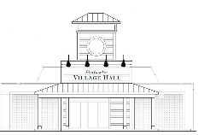 | 2026 RENEWAL FEE- $750.00  2026 PERMIT EXP. DATE: 12/31/2026  VILLAGE MGR. APPROVAL:  _________________________________

